**Interim Progress Report**

**on**

**EmAP :Emotion Analysis and Prediction using Stacked Machine Learning Algorithms and Classification Techniques**

**by**

**Abin Peter**

**List of Figures**

Figure 1: High Level Architecture Diagram 9

Figure 2: EDA Face Emotion Dataset 9

Figure 3: Sample Face Emotion Dataset 9

Figure 4: EDA Voice Emotion Dataset 9

Figure 5: Project Plan 10

Table of Contents

1 Introduction 4

1.1 Scope of Research 4

1.2 Research Questions 4

1.3 Project Aim 4

1.4 Objectives of Project 4

2 Literature Review 6

2.1 Text Sentiment Analysis using Natural Language Processing 6

2.2 Emotion Detection using Machine Learning 7

2.3 Emotion Detection using Deep Learning 7

3 Progress Summary 8

3.1 Data Collection 8

3.1.1 Data Background 8

3.1.2 Attributes of Data 8

3.2 Proposed Methodology 9

3.3 Present Progress of Work 10

3.3.1 Face Emotion Recognition Updates 10

3.3.2 Voice Emotion Recognition Updates 10

4 Issues of Present Research 11

4.1 Legal Issues 11

4.2 Ethical Issues 11

4.3 Social Issues 11

4.4 Professional Issues 11

4.5 Security Issues 11

5 Research Planning 11

5.1 Tool to be Used 11

5.2 Technology and Libraries 12

6 Project Planning 12

References 12

# Introduction

## Scope of Research

Emotion is the mental state that produces feelings while talking with others or expressing views on some incident. Generally, humans interpret emotions with a combined analysis of facial expressions, speech patterns, body posture, and text tone. Not only that, there are many permutations in which emotion can be expressed; people can have a sad facial expression, but the tone in which the conversation can convey a happy incident. Similarly, different combinations of these features can be used to express a particular emotion; thus, it is impossible to justify the result based solely on individual feature matrices mentioned before. The primary scope of the project is to create a stacked machine-learning model solution which collects the following;

1. Facial Emotion

2. Vocal Emotion

3. Text Emotion

The combined data and the ground truth can be used to create a machine-learning classification model which can be trained to predict emotions more accurately. The findings of this research can provide valuable insight into the potential of emotion extraction, with applications varying in fields such as psychology and marketing.

## Research Questions

The research questions that will be addressed at the end of the commencement of the research are as follows:

1. How can a stacked ML Solution can help in predicting emotion better than tradition single shot approaches?
2. How complex variation of emotions exhibiting from different aspect (facial, voice and text) can influence the overall decision making.

## Project Aim

The aim of the project is to create a stacked ML model that can take inputs from various emotion extraction models and predict the accurate emotion by training the model. This project will be then hosted as a web app and also provide a containerised API.

## Objectives of Project

The objectives of the research are as follows:

1. To gather knowledge regarding face emotion analysis, text sentiment analysis and voice sentiment analysis and emotions from the background study. Learn about the possible target data that can be acquired from existing or pretrained models

Time: 2 weeks

Outcome: Find models that can be used to collect emotions from face, voice and text and create a dataset that can be used for the project scope

1. Find video data which contain various emotions and expressions ideally over 1 hour long which can be used for preparing the training data for the models

Time: 1 week

Outcome: Create collection of image and audio files with annotations of emotion in each file

1. Create module that can extract all the confidence score from each emotion extraction model and make a dataset that can be used to fit into any classification models

Time: 1 week

Outcome: Setting up data extraction module which can help in pre-processing the required data.

1. To extract emotions from the text data using the text2emotion module and prepare the emotions in a new feature of the data.

Time: 1 week

Outcome: Extracting emotions of five types namely Happy, Sad, and Neutral. Set those emotions in a new feature of the data which will be taken as the feature for the detection of overall emotions.

1. To extract emotions Happy, Sad, and Neutral from image data using the face emotion extraction module and prepare the emotions in a new feature of the data.

Time: 1 week

Outcome: Extracting emotions of five types namely Happy, Sad, and Neutral. Set those emotions in a new feature of the data which will be taken as the feature for the detection of overall emotions.

1. To extract emotions from text data using the audio transcripts and covert the audio to text with a help of a pre-processing module and prepare the emotions in a new feature of the data.

Time: 1 week

Outcome: Extracting emotions of five types namely Happy, Angry, Sad, Surprise and Fear. Set those emotions in a new feature of the data which will be taken as the feature for the detection of overall emotions.

1. Find the best model that can be used for classification purposes using a python library to test out prediction parameters.

Time:0.5 Weeks

Outcome: Fixing a model which performs well

1. To compare the accuracy of the best-performing model with the existing approach to determine the research improvements.

Time: 0.5 week

Outcome: Identifying research improvement.

1. Create a web application using streamlit where each resource intensive process are converted to independent modules which can be run on any cloud hosting platform with the help of Kubernetes
2. Documenting the project outcome in the final project documentation.

Time: 2 weeks

Outcome: Final Project Document.

# Literature Review

## Text Sentiment Analysis using Natural Language Processing

According to, [1], a recognizable research field of DM is Sentiment Analysis demanding computational derivation of textual information and presently social media is the greatest source for supplying information regarding the behavioural mindset of individuals via comments and reviews. Despite variable implementations, the sentimental complexity restricted success, and demands for a narrative method for DA of sentiments facilitating precise prediction. The study facilitates a 3-tiered SAP solution to Text Trend via K-NN. It precedes via token transformation of sentences and stops word deduction followed by calculation of the polarity of the sentence, text, or paragraph, and concluding on the prediction of input text via K-NN classifiers.

According to, [2], the highly contagious covid-19 virus was detected on December 2019 originating in Wuhan, China extending its spread to 212 countries and territories globally infecting millions of populations and leading to the occurrence of worldwide lockdowns and encouraging people to resort to social media as a source for expressing their feelings and mental state. The study facilitates a tweet analysis via ML and a lexicon-based approach. The tweets considered are acquired from the RS Studio software ranging from a span of 30Th January-10th May 2020 comprising 11858 tweets. Each acquired tweet was analyzed via TextBlob separating them as Positive, Negative, or Neutral. The tweets can be pre-processed followed by preservation of the essential details via BOW and TF-IDF with RF, GBM, extra tree classifier, LR, and SVM finally segregating the beliefs as positive, negative, or neutral.

According to, [3], presently, variable ways like facial expression, gestures, speech, and text are opted by individuals for emotional expression, and with the noticeable growth of mobile applications leverages the significance of the accessibility apps as well with user reviews facilitating sufficient information boosting app evolution. Despite several applications, no noticeable implementation has been carried out using SA for better comprehension of user feelings regarding app accessibility. Thus, the study facilitates an accessibility dataset with two sentiment analyzers viz. TextBlob, and VADER inclusive of TF-IDF and BOW for sentiment polarity detection. Six classifiers namely LR, SVM, Extra Tree, GNB, GB, and AdaBoost can be implemented on the two sentiment analyzers with evaluation in terms of accuracy, precision, recall, and F-1 score.

According to, [4], as an essential aspect of NLP, the Chinese text SA leads to a comprehensive analysis of the Chinese text sentiment polarity. With the evolution of the DNN models, SA has turned into a progressive approach, and since NNs fail in the explicit derivation of sentiment insight, the study facilitates with the SINM model where Transformer Encoder and LSTM are considered as the components. Considering the Chinese emotional vocab, the sentiment insight in the Chinese text can be instinctively noticed. The SINM considers the text sentiment to leave behind illogical information. Experiments executed by considering the ChnSentiCorp, and ChnFoodReviews demonstrate SINM as a more suitable approach in terms of performance than others.

According to, [5], SA is the approach for the recognition and classification of text sentiment into positive, neutral, or negative categories. The two basics of SA are ML and lexicon-based approaches where BOW can be utilized for representing text as independent word vectors with ML facilitating classification. But the greatest drawbacks of the BOW are the Polarity Shift which alters the text’s sentiment polarity affecting classification efficiency. This polarity shift can be addressed via PS detection models where ML classification algorithms facilitate performance improvement and NLP helps in FE and classification.

According to, [6], SA carries out an analysis of sentiment and LDA is an essential approach for facilitating it which proceeds via derivation of the document’s topics represented as words with variable topic possibility. This demands data representation in the visual aspect easier for comprehension, and word cloud is such a category of data visualization. The research will carry out SA on University learners’ comments utilizing LDA and Topic polarity word cloud visualization. The aim of the study is to achieve TP word count utilizing the most suitable parametric combination followed by the comparison of the proposal to NB and LR and the outcomes depict that the proposed approach surpasses the LR and NB with 61% and 54% F-1 measures respectively.

## Emotion Detection using Machine Learning

According to, [7], Sarcasm is the greatest challenge for SA, and opinion summarization where its nature is responsible for carrying out the opinion in an insulting or humiliating manner. And classification occurs as per the words rather than the meaning which seriously impacts the accuracy. Sarcasm is harmful even for ED as it reflects the author’s opposite sentiments, and thus demands immediate sarcasm detection for identifying the sarcasm text and altering the text sentiment. As per recent studies, the utilization of both machine learners and deep learners facilitates suitable outcomes and can be widely applied for the purpose.

According to, [8], NP implementations portrays a significant role in everybody’s lives and the decisions initiated might not be right always and might comprise biases and exert serious impacts on the lives of individuals. These biases can be facilitated via dataset training, algorithmic use, etc. The study facilitates SA of gender in a facilitated dataset considering both English and Turkish dataset followed by the comparison of the obtained outcomes. The comparison was initiated via variable FE approaches and the classical ML application

According to, [9], Internet and Microblogging sites are utilized by individuals for expressing their reviews n products or services and SA of the public views is utterly necessary as it facilitates insight into public opinions on a particular service and on the customer’s behaviour while product’s purchase. These aspects are extremely vital for the analysis of brand awareness in public and private sectors with the proposed campaign supporting the understanding of various algorithms utilized for segregating the appearing texts under variable groups.

According to, [10], the Internet revolution brings about noticeable alterations in terms of online education, homes-offices, online shopping, etc. Social media is the most noticeable outcome of the Web without any doubt and is the platform for expressing one’s thoughts and feelings too. These results in the gathering of huge online data, and also demand an automated classification system. In certain instances, demand for SPD becomes irresistible like positive or negative labelling of a product is enough for providing a review regarding the product. For addressing the issue, the study facilitates with TR and ML approaches like SVM, NN, NB, and DBSVM combined into a single model considering the three public datasets of CornellPD, HUMIR, and SerbSPD-2C in English, Turkish, and Serbian languages respectively.

According to, [11], the study deals with SA in textual documents specifically TV detection. And the presented solution is specified on the SVM classifier. The classifier is fine-tuned via an extreme proportion of data and complicated word combinations are assessed considering dispersed learning on 112 processors. The considered dataset for training and examination was gathered from real-time user reviews on products of variable web pages and the proposal was evaluated in English, German, Czech, and Spanish languages. An accuracy of 11% achieved in terms of Big Data is present in the study with the highest accuracy of 95.31% gained in terms of the distinction between positive and negative text valence.

## Emotion Detection using Deep Learning

According to, [12], Social Media has turned into a suitable communicative platform for individuals to express their feeling which they seldom do in physical interactions, and the detection of sentiments and emotions from the gathered texts has turned into a recognizable approach. The noticeable role of the Arab region in international policies and in the Global economy facilitates Arabic sentiments and emotion analysis. The study deciphers the SEDAT for identifying the sentiments in Arabic Tweets and the performance outcomes can be obtained via implementation of the word and document embeddings, a set of semantic characters along with CNN-LSTM, and completely linked NN models.

According to, [13], SA is the procedure of implementing NL processing and text-based approaches for extracting the subjective insight of text. NLP and TC are capable of tackling the restricted corpus data providing prioritization to the semantic texts and WE approach. DL is a stringent approach that comprehends variable strata of information qualities presenting with traditional prediction outcomes. SA can be applied to sentences, documents, etc. with the study focusing on the complexities of SA impacting the sentiment count, poling, and polarity. The most recognized DL approaches are CNN and RNN respectively.

According to, [14], the aim of SA is text opinion or polarity detection and can be used for detecting negative sentiments depicting abnormal activities in the OS logs. The prevailing approaches include manual browsing, pre-defined objectives, or ML approaches for identifying such an event but the article facilitates a narrative approach based on the DL-oriented SA method for assuring the presence of abnormalities in the OS logs. LOG messages are structured as sentences and are recognized using the GRU networks. The experimental outcomes depict the model’s suitability in the identification of abnormal activities in the OS logs with an accuracy of 99.84%.

# Progress Summary

## Data Collection

The data which will be selected from the detection of text emotions will be collected from Kaggle [15]. This data will be used for the purpose of research to detect the emotions from the texts.

TESS (Toronto Emotional Speech Set) [16]dataset is collected from Kaggle to train speech emotion sound classification. This data will be used for the purpose of research to detect the emotions from the Audio Files.

face-expression-recognition-dataset [17] is a collection of facial expressions images which can be used to train a classification model to extract emotions from image features.

Combined Facial Expression dataset (custom data) is a collection of prediction provided by each emotion extraction model. The score of each features are collected together with voice, face and text emotions then a ground truth will be labelled an manually annotated. This will create a baseline for out classification algorithm

### Data Background

The data will be a collection of prediction results from the different ML models which is then combined to form a dataset of numerical values and labels results. To achieve this several videos of humans expressing emotions in a complex manner is required to create a variety of data. This will help the classification algorithm to properly extract valuable predictions. The objective is to get a video of at least 1 hour and cut it into sections of 5 second snippets. The voice, face and text prediction results are then collected for each snippet and stored in a data frame with annotated ground truth.

### Attributes of Data

Total expected data points : 1000

1. FileName :- The filename of the video segment of 5 Sec (str)
2. Voice_mmfc : Audio feature of the selected file clip (array)
3. Raw_text: Speech to text of the selected audio clip (str)
4. Face_Happy_Score: The confidence score for facial recognition label happy (0-1)
5. Face_Sad_Score: The confidence score for facial recognition label sad (0-1)
6. Face_neutral_Score: The confidence score for facial recognition label neutral (0-1)
7. Voice_Happy_Score: The confidence score for voice recognition label happy (0-1)
8. Voice_Sad_Score: The confidence score for voice recognition label sad (0-1)
9. Voice_neutral_Score: The confidence score for voice recognition label neutral (0-1)
10. Text_Happy_Score: The confidence score for text recognition label happy (0-1)
11. Text_Sad_Score: The confidence score for text recognition label sad (0-1)
12. Text_neutral_Score: The confidence score for text recognition label neutral (0-1)
13. FinalEmotion: Label of the emotion (0-neutral,1-positive,2-negative)

## Proposed Methodology

1. **Data Collection Module:** Raw data collected from video files that is at least 1 hour long, in which contains varied emotions with face close shots as well as clear audio of the individuals voice, The primary language used for this research is English.
2. Data Processing Module:
   1. Segmentation Module : This module will trim the entire video file to 5s chunks and save the data in a new folder called file_id_chunks and each file will be named in the format of *fileid*_cnk_*number* . The folder name and file name will be combined and stored in a dataframe
   2. Audio Extraction Module : The dataframe which contain chunk information are loaded and each chunk is selected to extract the text as well as the Mel-frequency cepstral coefficients of the audio file. The text is saved to colmn “Speech to Text” and the latter stored in mfcc column.
3. Emotion Extraction Module:
   1. FaceEmotionPredictor Module: This module inputs the video chunk and extract the frames and saves it in a folder , This frames are then passed to a Face Sentiment extraction model to get the confidence score for each emotion. This data is then passed to the main dataframe as Face_negative,Face_positive,Face_neutral
   2. VoiceEmotionPredictor Module: This module inputs audio for the chunk and extract features to pass into the voice emotion prediction model which is build on a LSTM Neural Network .
   3. AssembleAI Speech Emotion Extractor Module : To enhance the results even further existing API which perform voice emotion prediction is used to cross verify the results. This API will be able to extract the text as well as the emotion score for the audio clip.
   4. Text Emotion Extractor Module: Using a pretrain transformer, the text collected from the speech to text model will be used to extract each emotions and stored in the dataframe.
4. Combined Emotion Prediction Module
   1. This module will be trained on the results generated by the emotion extraction module as well as the ground truth which will be annotated manually.

Data Collection and Processing Module

Video Input

Stacked ML

Facial Emotion

Voice Emotion

Text Emotion

Custom Dataset

Custom Classification Model

Results

Figure 1 : High level architecture

## Present Progress of Work

### Face Emotion Recognition Updates

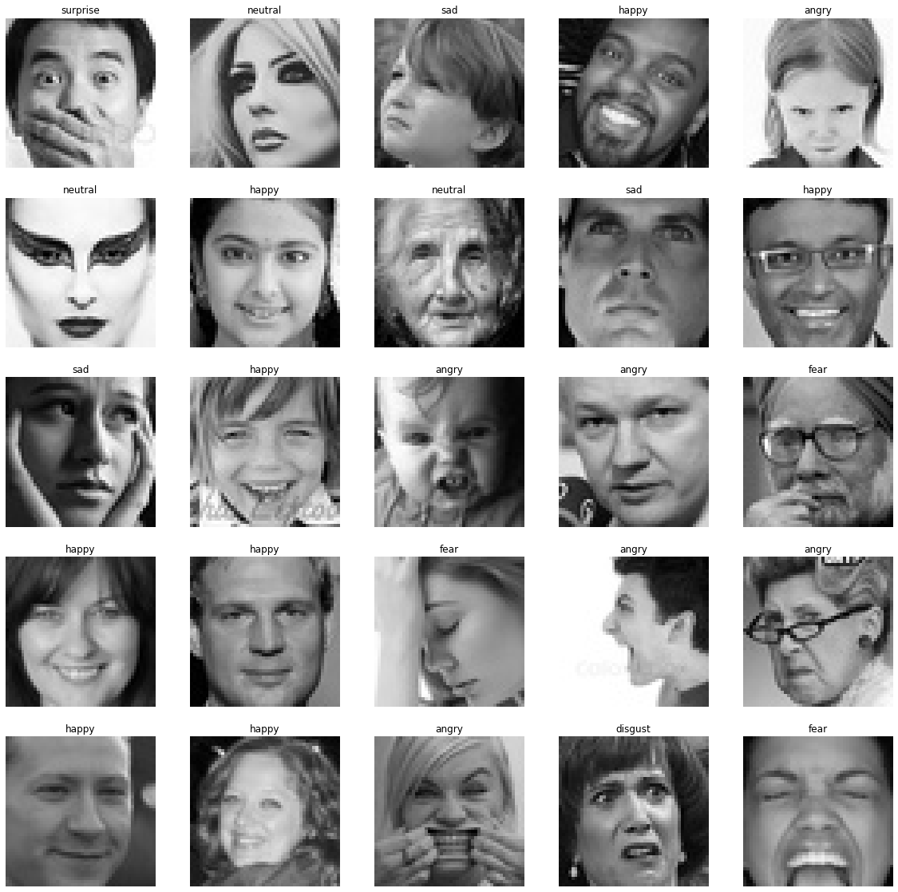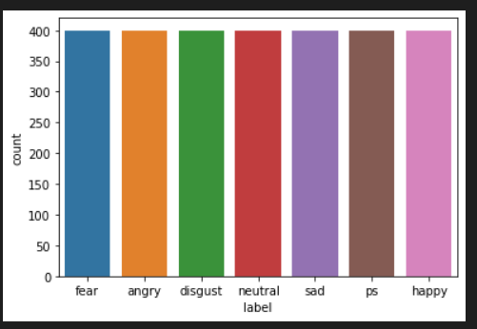

Figure 2 : EDA of Face Emotion Dataset

Figure 3 : Sample of Face Emotion Dataset

### Voice Emotion Recognition Updates

Figure 4 : EDA of Voice Emotion Dataset

# Issues of Present Research

## Legal Issues

All kinds of legal protocols are needed to be followed by the research regulatory bodies and sometimes are also confronted by the Legal challenges associated with criminalities which are seriously needed to be addressed and resolved as well as followed data protection assurance along with the maintenance of integrity and confidentiality of the acquired data gathered especially for the research conduct.

## Ethical Issues

The incorporation of Machine Learning and Deep Learning for sentiment and emotion detection is extremely is expected to abide by the ethical protocols which encourage both data security and data privacy respectively during the accomplishment of such methodologies and also highlight text analytics as well.

## Social Issues

The processes utilized for sentiment and emotion detection via the utility of machine learning and deep learning inclusive of processing and classification must limit themselves from any kind of discrimination or inequality of certain data security protocols and also abide by the protocols related to the privacy and security of user information.

## Professional Issues

The purpose of machine learning and deep learning under expert monitoring is required to possess the capability of carrying out the approaches efficiently in terms of emotion detection. Under any situation of data infringement or loss, the experts must be capable of efficient situation handling. They are also required to implement their abilities and expertise for ignoring any forms of data theft or other security disturbances while proceeding forward with the research proceedings.

## Security Issues

The Tackling of the alteration or damage of data caused to the loss of sensitive research proceedings and documents must be undertaken as an essential aspect of the experimental procedures. Unnotified access or utilization of crucial research whereabouts without prior concern must also be restricted for the purpose of experimental trustworthiness and loyalty.

# Research Planning

## Tool to be Used

1. Visual Studio Code
2. Google Colab
3. Github
4. Docker Desktop

## Technology and Libraries

In this research, the technologies and libraries that will be used are as follows:

* Data reading and Analytics: Numpy, Pandas
* Data Visualization: Matplotlib, Seaborn, Plotly Express
* Text Analytics: NLTK, Text2Emotion [17]
* Text Feature Extraction through Vectorization process: Scikit Learn
* Machine Learning for Classification: Scikit Learn
* Text Pretrained Model : cardiffnlp/twitter-roberta-base-sentiment from huggingface

# Project Planning

The tentative planning for the research is shown below:

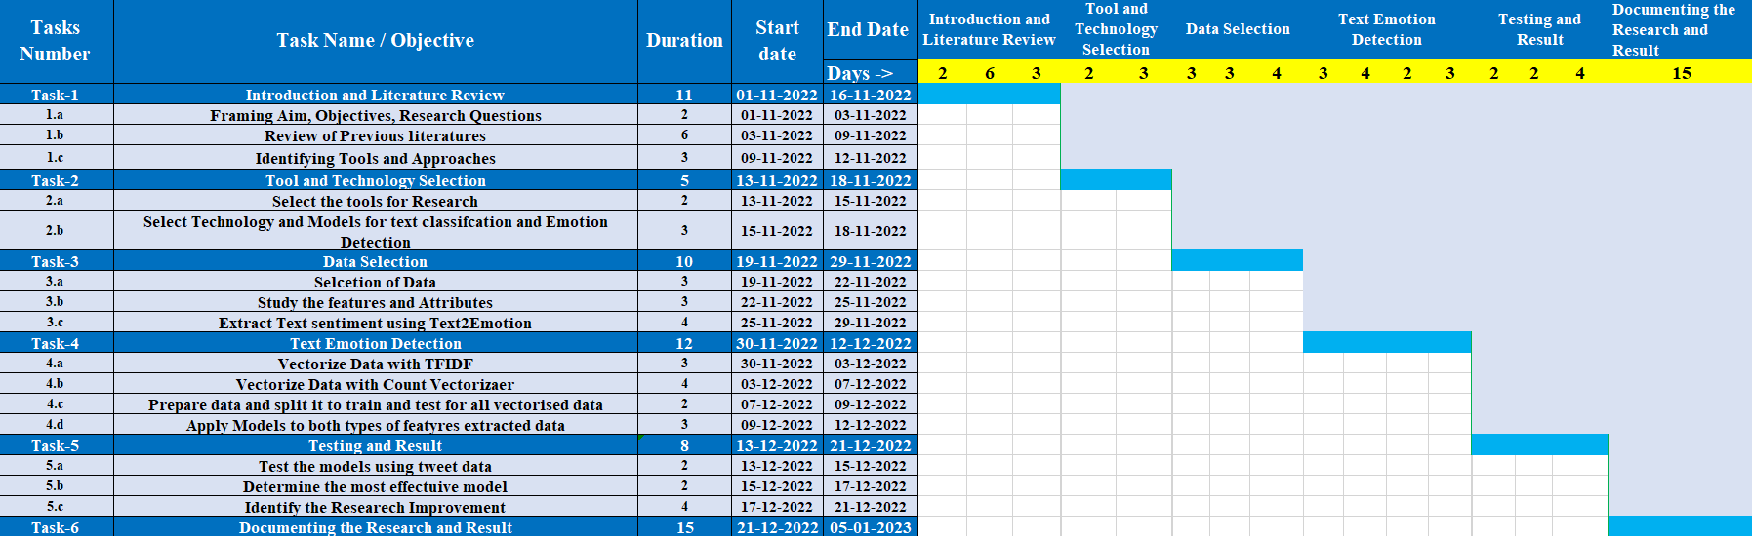

Figure 5 : Project Plan

# References

|  |  |
| --- | --- |
| [1] | A. Razzaq and M. Asim, “Text sentiment analysis using frequency-based vigorous features,” *China Communications, vol. 16, no. 12,* pp. 145-153, 2019. |
| [2] | R. Khan, “US Based COVID-19 Tweets Sentiment Analysis Using TextBlob and Supervised Machine Learning Algorithms,,” *2021 International Conference on Artificial Intelligence (ICAI),,* pp. 1-8, 2021. |
| [3] | W. Aljedaani and F. Rustam, “Learning Sentiment Analysis for Accessibility User Reviews,,” *2021 36th IEEE/ACM International Conference on Automated Software Engineering Workshops (ASEW),* pp. 239-246, 2021. |
| [4] | G. Li and Q. Zheng, “Sentiment Infomation based Model For Chinese text Sentiment Analysis,,” *2020 IEEE 3rd International Conference on Automation, Electronics and Electrical Engineering (AUTEEE),,* pp. 366-371,, 2020. |
| [5] | S. Zirpe and B. Joglekar, “"Polarity shift detection approaches in sentiment analysis: A survey,",” *2017 International Conference on Inventive Systems and Control (ICISC),,* pp. 1-5, 2017. |
| [6] | M. F. Bashri, “Sentiment analysis using Latent Dirichlet Allocation and topic polarity wordcloud visualization,” *2017 5th International Conference on Information and Communication Technology (ICoIC7),,* pp. 1-5, 2017. |
| [7] | P. H. Lai, “Ensembles for Text-Based Sarcasm Detection,",” *2021 IEEE 19th Student Conference on Research and Development (SCOReD),,* pp. 284-289, 2021. |
| [8] | H. Dervisoglu, “Bias Detection and Mitigation in Sentiment Analysis,” *2021 Innovations in Intelligent Systems and Applications Conference (ASYU),,* pp. 1-6,, 2021. |
| [9] | P. Santhiya, “Sentiment Analysis Classifiers for Polarity Detection in Social Media Text: A Comparative Study,” *2021 5th International Conference on Electronics, Communication and Aerospace Technology (ICECA),,* pp. 1407-1411,, 2021. |
| [10] | J. Graovac, “"ML-SPD: Machine Learning based Sentiment Polarity Detection,” *2020 International Conference on INnovations in Intelligent SysTems and Applications (INISTA),,* pp. 1-7,, 2020. |
| [11] | L. Povoda, “"Sentiment analysis based on Support Vector Machine and Big Data,,” *2016 39th International Conference on Telecommunications and Signal Processing (TSP),* pp. 543-545, 2016. |
| [12] | M. Abdullah, “"SEDAT: Sentiment and Emotion Detection in Arabic Text Using CNN-LSTM Deep Learning,” *2018 17th IEEE International Conference on Machine Learning and Applications (ICMLA),,* pp. . 835-840,, 2018. |
| [13] | M. Anusha, “Analysis on Sentiment Analytics Using Deep Learning Techniques,” *2021 Fifth International Conference on I-SMAC (IoT in Social, Mobile, Analytics and Cloud) (I-SMAC),,* pp. 542-547,, 2021. |
| [14] | H. Studiawan, “Anomaly Detection in Operating System Logs with Deep Learning-Based Sentiment Analysis,,” *IEEE Transactions on Dependable and Secure Computing, vol. 18, no. 5,* pp. 2136-2148, 2018. |
| [15] | P. Gupta, “Emotion Detection from Text,” 2020. [Online]. Available: https://www.kaggle.com/datasets/pashupatigupta/emotion-detection-from-text. |
| [16] | K. . Dupuis and M. K. Pichora-Fuller, “Toronto emotional speech set (TESS) - Younger talker_Disgust,” , 2010. [Online]. Available: https://tspace.library.utoronto.ca/handle/1807/24498. [Accessed 16 12 2022]. |
| [17] | S. Sharma, “Detecting emotions behind the text,” 2020. [Online]. Available: https://shivamsharma26.github.io/text2emotion/. |
| [18] | F. H. Rachman, R. Sarno and C. Fatichah, “CBE: Corpus-based of emotion for emotion detection in text document,” *3rd International Conference on Information Technology, Computer, and Electrical Engineering (ICITACEE),* pp. 1-6, 2016. |
| [19] | G. Jain, S. Verma, H. Gupta, S. Jindal, M. Rawat and K. Kumar, “Machine Learning Algorithm Based Emotion Detection System,” *Fifth International Conference on Computational Intelligence and Communication Technologies (CCICT),* pp. 1-4, 2022. |
| [20] | M. A. Mahima, N. C. Patel, S. Ravichandran, N. Aishwarya and S. Maradithaya, “A Text-Based Hybrid Approach for Multiple Emotion Detection Using Contextual and Semantic Analysis,” *International Conference on Innovative Computing, Intelligent Communication and Smart Electrical Systems (ICSES),* pp. 1-4, 2021. |
| [21] | F. A. Acheampong, H. Nunoo-Mensah and W. Chen, “Recognizing Emotions from Texts Using an Ensemble of Transformer-Based Language Models,” *18th International Computer Conference on Wavelet Active Media Technology and Information Processing (ICCWAMTIP),* pp. 1-5, 2021. |